**PROJECT-NAME: BYJU CLONE**

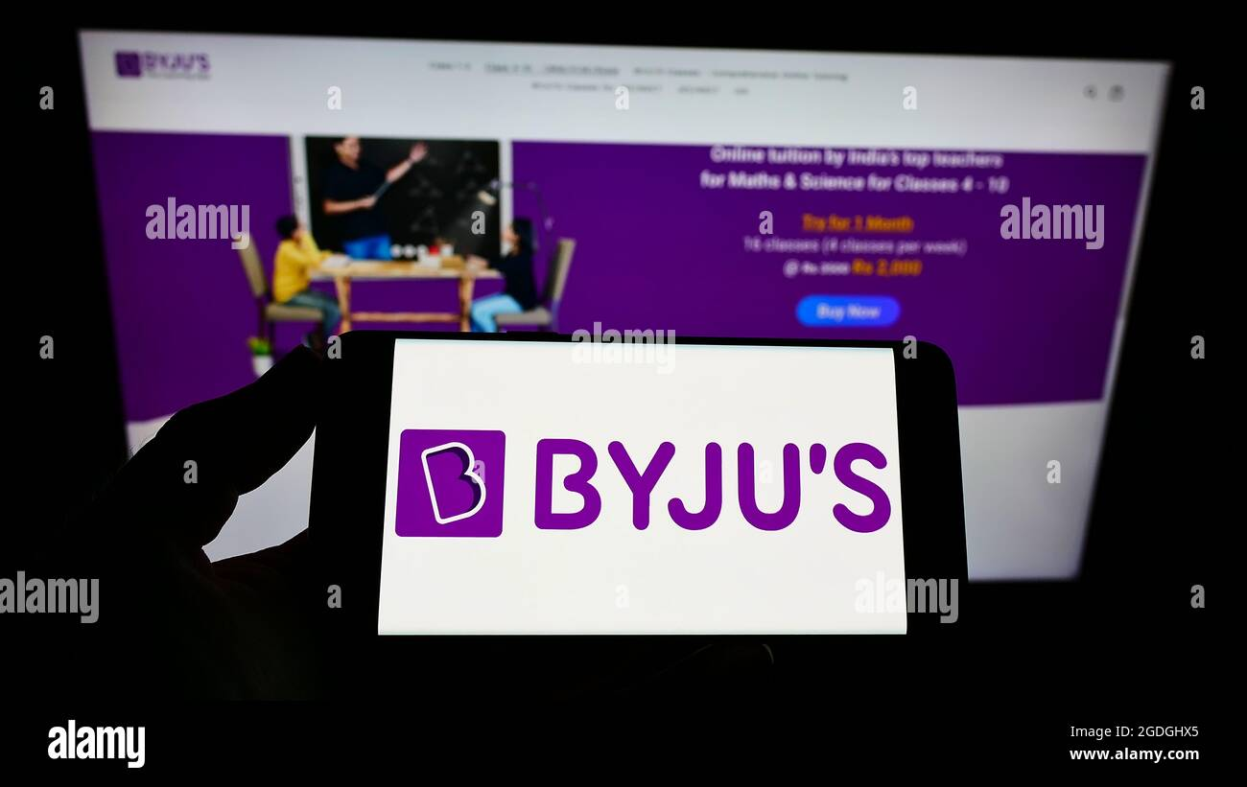

**\*OVERVIEW: BYJU'S is a global ed-tech company, providing highly adaptive, engaging and effective learning solutions to more than 150 million students around the world. Founded in India in 2011, BYJU'S mission is to make high-quality learning accessible to students everywhere.**

1. **HOME PAGE:**

# LOGO

# ICONS - (WISHLIST, ADD TO CART)

# SEARCH BAR

# SLIDERS WITH ARROWS - (IMAGES)

# DEALS - (IMAGES)

# FEATURED STUDY MATERIAL - (IMAGES)

# TRENDING COURSES - (IMAGES)

# FOOTER – ( CONTACT US , HELPLINES , BRIEF DESCRIPTION

ABOUT THE COMPANY , SOCIAL-MEDIA HANDLE

ICONS , LINK TO MOBILE APP )

1. **BOOK YOUR FREE CLASS:**

# NAME OF YOUR CHILD

# MOBILE NUMBER

# EMAIL & STATE PREFERENCE

**3. MAIN PAGE:**

# IMAGES OF THE CHOSEN PRODUCT WITH DETAILS LIKE -

( COURSES, COURSES NAME , PRICE , DISCOUNT% ( IF

ANY ) )

# ON CLICKING THE IMAGE - (MULTIPLE IMAGES OF THE

COURSES WILL APPEAR FROM DIFFERENT ANGLES ,

ZOOM IN , ZOOM OUT)

# COURSES DESCRIPTION – (COURSES , COURSE NAME ,

PRICE , DISCOUNT% (IF ANY) , CLASSES ,

COMPETETIVE EXAM COURSES , COURSES

RATINGS , REVIEWS)

1. **PAYMENT PAGE:**

# ADDRESS SELECTION

# PAYMENT METHOD - (PHONEPE , GOOGLE PAY , BHIM UPI ,

COD , CREDIT/DEBIT CARD , NET

- BANKING , EMI , PAYTM)